WEEK 4: OPERATONS RESEARCH

1. Linear Programming Problem: Maximizing Profit

Problem Formulation
The objective was to maximize profit for a company manufacturing two products, A and B, subject to resource constraints. The details were as follows:
- Profit per unit of Product A: $30
- Profit per unit of Product B: $45
- Raw material required for Product A: 3 kg/unit
- Raw material required for Product B: 5 kg/unit
- Labor required for Product A: 4 hours/unit
- Labor required for Product B: 2 hours/unit
- Total available raw materials: 120 kg
- Total available labour: 160 hours
Objective Function: Maximize 30A+45B
Constraints:
- Raw Material: 3A + 5B ≤ 120
- Labor: 4A + 2B ≤ 160
- Non-negativity: A,B ≥ 0
Problem and Results by Solution Approach
With the help of simplex method, a maximum profit of $1200 could be obtained by producing 40 units of Product A and not producing Product B at all. It implies that the company should concentrate on making Product A only because it has a lower cost per unit.
Visualization
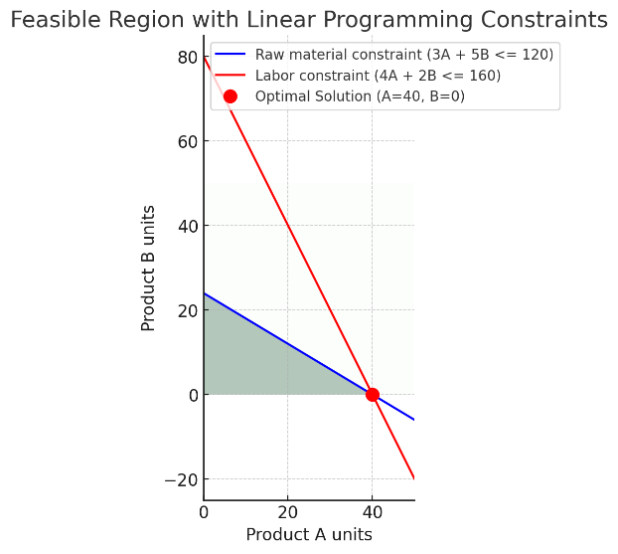
A scatter plot with optimal production point was produced to show how constraints intersect within feasible region. This visually demonstrated the presence of a feasible region bounded by intersecting constraints, where the optimal point lies, satisfying the objective function optimization criteria under certain conditions.

- Minimization of Supply Chain Cost
Problem Formulation
In an idealized supply chain model, transportation costs through many paths connecting suppliers to customers had to be minimized. The model included determining how much product needs to be sent along each route so as to minimize overall transportation costs and meet demand and supply limits.
Solution Approach and Results
Linear programming model comprising cost coefficients for each route was formulated specifying constraints based on supply capacities and demand requirements. The solver easily found shipping quantities that minimized costs subject to all such conditions.
Visualization
There are graphical representations that enable anyone to understand the supply chain flows, indicating optimal routing and quantities. The graphics allowed intuitive understanding of the logistics operations, making it easier for decision makers to make decisions as well as communicate with all involved stakeholders.
Data Storytelling And Analysis
Formulation Significance
Objective Function: It is at the centre of any optimization; it helps align solution with strategic goals which may either be profit maximization or cost minimization.
Constraints: These reflect real world limitations ensuring feasible and applicable solutions. They are very important in defining the solution space and determining where optimal solutions can be found.
Discussion Of Results
Both scenarios’ solutions show how powerful linear programming can be in strategic decision making. In maximizing profit problem, the model shifted production strategy towards exploiting most profitable opportunities within resource limits. For minimizing costs, the model gave a guide to efficient allocation of resources across supply chain.
Conclusion
The use of linear programming and optimization models provides significant advantages in decision-making through quantifying trade-offs and identifying best strategies under constraints. The visualization combined with data storytelling also improves comprehension and communication on these kinds of issues.

