WEEK 1: DATA CLEANING
This week, I performed a simple data cleaning of a dataset on housing in California. To load the dataset onto Jupyter, I used Pandas as the variable pd. Then I imported the csv excel file onto Jupyter and onto the code using another variable called df.
I then checked if any of the values in the dataset are null values (missing). I found that the number of total bedrooms were missing for some rows. So, in order to complete the dataset, I replaced them with the number 0.
I also checked if any of the values were duplicated, if they appeared twice in the dataset, I deleted one of the values.
To create a histogram for visualization, I used matplotlib. I used the plt.hist() function to create the histogram.
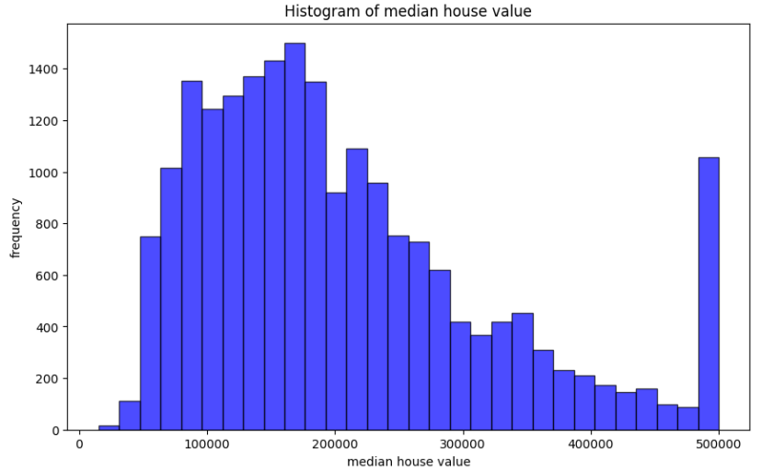

I also created a function to handle outliers in the dataset which would handle them by removing or deleting them entirely from the dataset. This would help in plotting the mean and statistical analysis later on in the data analysis.
I also used a boxplot to better find the outliers in the dataset graphically using the plt.boxplot() function.
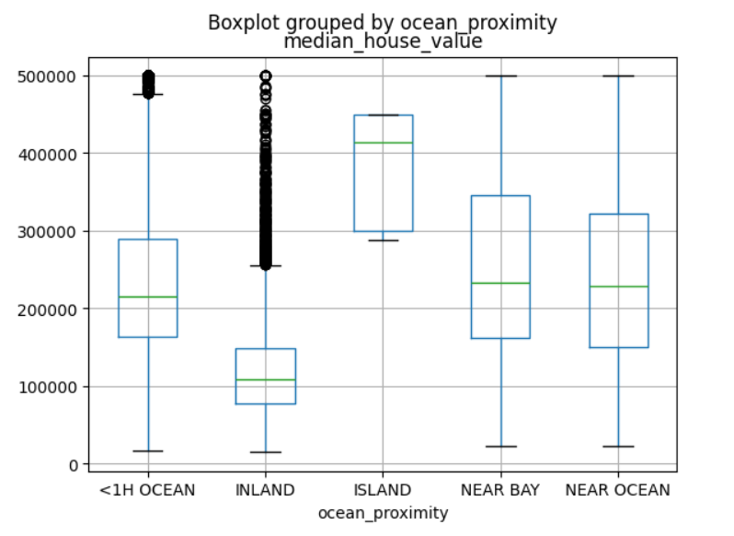

This data cleaning process was essential in transforming the raw housing data to a reliable dataset suitable for data analysis. The cleaned data provided valuable insights that invoke decision-making and operational improvements.
The data cleaning also provided an easy way to visualize the data in a graphical manner and the graphs appeared a lot more organized after the cleaning.

