WEEK 3: SUPERVISED LEARNING AND MODEL PERFORMANCE
Dividing the Data
Dividing our data into training and testing sets such that both sets are representative of the overall dataset is very important for assessing the performance of a model effectively.
Choice and Making Model
Regression Model: Linear regression was chosen for predicting median house value. It is a simple yet powerful technique for regression tasks.
Classification Model: Logistic regression was preferred for binary classification problem of predicting whether a house’s cost would be high or low because it is good at handling binary outcomes and provides probabilities for class memberships.
Training Models
Training each model on the training dataset involves some form of adjustment to the model parameters to minimize prediction error, e.g., by gradient descent in logistic regression.
Evaluation of Models
Regression Model Evaluation: Mean squared error (MSE) and R-squared were used. The MSE gives an indication of average difference between expected values and actual values thereby gives us an idea about how much mistakes we have made in predictions. For knowing how closely our model’s predicted values represent the variability contained in that data set, we looked-up R-squared value.
Classification Model Evaluation: Our primary measure was the accuracy of our classification model, which we complemented with a confusion matrix to show how well the model correctly predicted both classes.
Visualization
The scatter plot helped us to evaluate closely the data points’ fit to the ideal line and it is shown by plotting actual values against predictions made by regression model. Classification model’s performance was able to be understood through a confusion matrix however that came up with true negatives, true positives, false negatives and false positives hence making it clear about its misclassifications and accuracies.
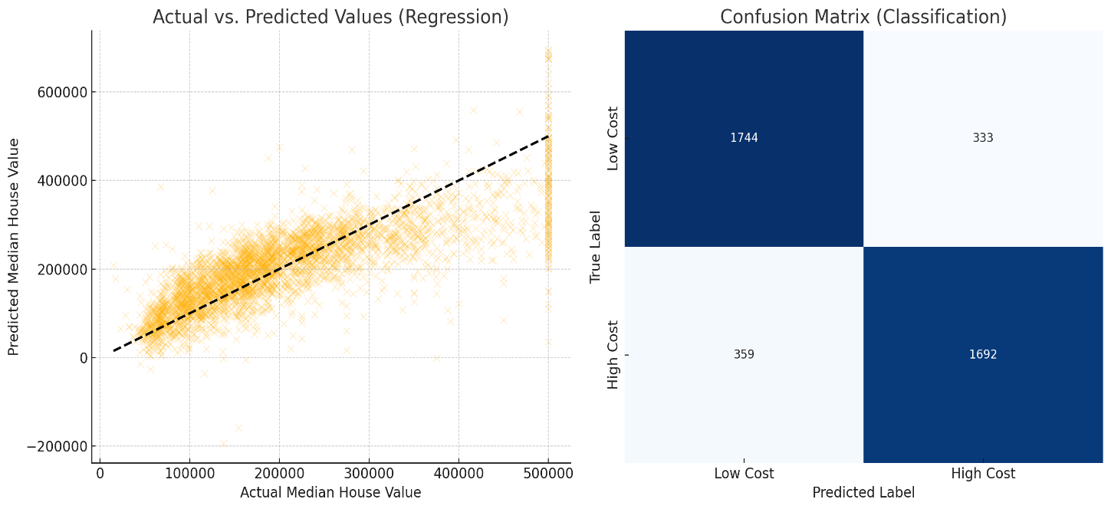
Key Decisions:
Selection of models best suited for each task according to the nature of target variable.
Preprocessing stages that err on specific issues of data such as missing values and categorical variables.
Metric selection based on what best represents success for each type of model, focusing on accuracy and confusion matrix for classification, and MSE and R-squared for regression.
Performance Highlights:
A moderate fit was indicated by R squared value computed from this regression model suggesting that though it captures sufficient variances more improvement is possible with either complex models or feature engineering.
The high accuracy in classifying blocks as high-cost or low-cost indicates that our classification model is quite efficient.

